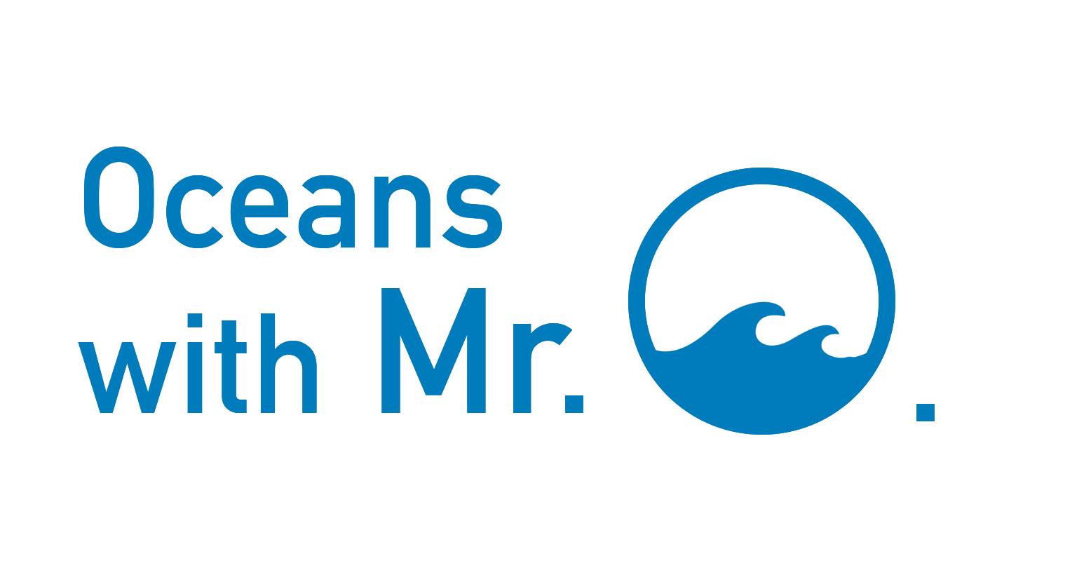
Oceans with Mr. O.
Video Module 1.2:
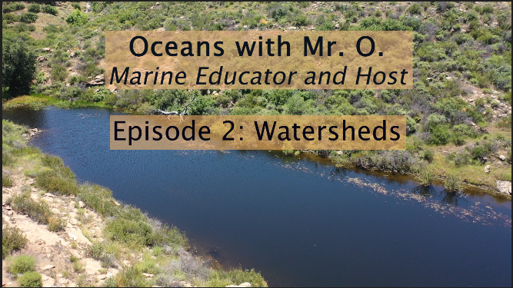
Watersheds
Table of Contents
Video discussion questions and sample answers: 3
Tools and connections to NGSS in the following ways: 6
HS.Earth Systems 6
HS-ESS2-5. Plan and conduct an investigation of the properties of water and its effects on Earth materials and surface processes. 6
HS-ESS2-6. Develop a quantitative model to describe the cycling of carbon among the hydrosphere, atmosphere, geosphere, and biosphere. 7
HS Weather & Climate 8
HS-ESS2-4. Use a model to describe how variations in the flow of energy into and out of Earth’s systems result in changes in climate. 8
HS-ESS3-5. Analyze geoscience data and the results from global climate models to make an evidence-based forecast of the current rate of global or regional climate change and associated future impacts to Earth systems. 9
HS Human Sustainability 10
HS-ESS3-1. Construct an explanation based on evidence for how the availability of natural resources, occurrence of natural hazards, and changes in climate have influenced human activity. 10
HS-ESS3-4. Evaluate or refine a technological solution that reduces impacts of human activities on natural systems.* 11
Links, articles, and pages for further researching and resources: 13
Handy glossary relevant terminology: 14
Image Gallery 17

Video discussion questions and sample answers:
- “How can a stream in the mountains make its way to the ocean or another large body of water?” {1:48}
  - Gravity is the principal force that pulls water from higher elevations to lower elevation where lakes and the ocean are.
  - Water reaches the surface of the mountains in the form of precipitation. Precipitation can come in many forms, but commonly rain, drizzle, snow, and hail.
  - The precipitation collects on the surface of the mountains and flows downhill, the path of least resistance, toward a valley or gulley where it collects with other water and gains speed forming a creek, stream, or river.
  - It is worth noting that water also percolates through the soil into groundwater aquifers where it will reach a saturated layer and still flow downhill, just underground.
  - From rivers and streams, water will meet up with other flows in lakes or bays in the ocean.
- “How would land development of the headwaters by humans affect our watersheds and our oceans?” {5:54}
  - The headwaters are often the most pristine part of a watershed, and developing the land around it has drastic implications for the health of the ecosystems downstreams.
  - Resupply of water to the watershed will be altered. Development often brings with it a change in surface structure, for example soil and porous dirt to asphalt and concrete. This changes how water will runoff potentially leading to floods, or prevents percolation that replenishes aquifers.
  - Humans often bring pollution with them. Oils, litter, wastewater, dirt and particulate matter, and many other examples of byproducts of developing land will change the chemistry of the ecosystem. All of the physical pollutants make their way into the ocean and affect wildlife there. Noise and light pollution in headwaters habitat also affect vulnerable wildlife.
  - Damming rivers as a source of freshwater and energy for cities changes much of the ecosystem, including the wildlife that live within the river. Riparian habitat and soils are used to periodic flooding, but dams control the amount of water constantly flowing and reduce outflow thus drying out habitat downstream.
  - Estuaries down by the ocean need a constant inflow of freshwater and when rivers are being choked and drained, the estuaries no longer can support the uniquely adapted organisms that need the brackish water.
  - Rivers also are a source of micronutrients like phosphorus and iron that many marine organisms need trace amounts of. By altering the flow upstream, a limited amount of these natural elements make it to the ocean.
- Channelizing and changing the flow of a river affects the ecosystem around it by… {6:27}
  - Restricting flooding to protect property and damages restricts water saturating into the soil and habitat surrounding the river.
  - Channelizing a river instead of letting it meander causes water speed to increase and can be dangerous for organisms in the river and in the ocean where it outputs. This can also increase erosion downstream where the river is not channelized by concrete.
  - Humans living next to rivers and waterways leads to a number of threats to the habitat, see above question for similar answers.
- “What indicators would you use to measure the health of a watershed?” {8:40}
  - Because rivers are sensitive ecosystems, there are lots of ways to gauge the overall health. Some methods for checking as as follows:
  - Abiotic -the nonliving components of the ecosystem - occur in an environment and can indicate overall health. For example, a lot of dams have a flow rate, a number determined by scientific experts, they must release to maintain a balanced ecosystem downstream. So watching a river's flow rate can be indicative of health. Another measurement used can be dissolved oxygen that specific tools are able to record.
  - Biotic - living components of the ecosystem - respond to changes in the physical and chemical properties of the river. Many scientists look for the presence or absence of highly sensitive species like benthic macroinvertebrates (large bottom dwelling grubs). Many of these invertebrates are used as bioindicators, sensitive species that can determine the health of an ecosystem. For example, some insect nymphs can not exist if there is not adequate dissolved oxygen in the stream. The other side of the coin is for example too many of one type of invertebrates means the ecosystem is unbalanced.
- How would you manage the watershed ecosystem and the resources they provide? {11:46}
  - This is a very challenging question, and many experts in the field still debate ways to efficiently and effectively manage watersheds and ecosystem services.
  - There are many factors and variables that need to be considered in the management process. Some factors to include are:
    - Human population and immediate human impacts
    - Infrastructure, urban growth, and development
    - City proximity and footprint on the environment
    - Waste management
    - Presence of endangered and threatened species
    - Biodiversity and endemism
    - Seasonality and natural fluctuations of river and water
    - Resource alternative
  - Management is a constant effort and requires constant monitoring and reevaluation.
- What are some everyday activities you and your community can do to help your watershed? {13:07}
  - Trash cleanups - grab some friends, gloves, grabbers, buckets and bags and pick up all the human trash that you see. You can do a cleanup along the river, in a park, along the street, or anywhere, because as we have seen, everywhere is part of a watershed.
  - Use less water - take shorter showers, turn off faucet when brushing your teeth, flush the toilet less frequently (or get dual flush toilets). Using less municipal water puts less strain and demand on the limited freshwater resources allowing more to remain in nature.
  - Pick up after your pet - animal waste that is not disposed of properly ends up in the river and in the ocean and causes harmful microorganisms to grow and unbalance the ecosystem.
  - Plant native species - ask a local nursery or research what plants belong in the ecosystem and plant them in your yard or community center. Bonus points if you identify invasive plants and remove them as well. Seek out an expert for advice on what plants should and shouldn’t be present in your region of the watershed.
  - Take your car to a local recycled water car wash instead of washing your car in your driveway. Soaps, oils, and fine metals come off your car and enter the waterway through runoff.
  - Yard waste - Clean up greens and grass clippings in the proper bins. If your city has infrastructure to pick up garden waste, collect your greens there. Grass clippings can clutter rivers and streams when carried by runoff and decompose quickly sucking up oxygen from the river.
  - Donate - if you or your family have means to spare, donate your money or time to volunteer for a local nonprofit that is helping your local watershed.
  - Vote - if you are of age or can encourage someone of voting age to ask and support candidates in your local government who care about watershed and resource management.
  - Educate your community - everyone should know their actions impact the environment both local and globally. Encourage them to participate and learn what is helpful to protect their watershed.

Tools and connections to NGSS in the following ways:

HS.Earth Systems

HS-ESS2-5. Plan and conduct an investigation of the properties of water and its effects on Earth materials and surface processes.
  - [Clarification Statement: Emphasis is on mechanical and chemical investigations with water and a variety of solid materials to provide the evidence for connections between the hydrologic cycle and system interactions commonly known as the rock cycle. Examples of mechanical investigations include stream transportation and deposition using a stream table, erosion using variations in soil moisture content, or frost wedging by the expansion of water as it freezes. Examples of chemical investigations include chemical weathering and recrystallization (by testing the solubility of different materials) or melt generation (by examining how water lowers the melting temperature of most solids).]

Engage | How does water, a substance this planet is known for, react with various mixed solvents? Do you think water can ever be restored to its purest natural state? Can water be created or destroyed?  Another approach is to engage students in thinking about bodies of water. How does water stay together as one unit? How does water flow through the environment in the form of runoff or river?
Explore | Activities:  - Experiments with the properties of water for example a jar of water mixed with various substances like soap, oils, sediment, saltwater, ice. Shake it up and see how water reacts immediately and then over time.  - https://www.horizonsd.ca/Services/Curriculum/Documents/Chemistry%20B%20-%20Lesson%201%20-%20Water%20Properties.pdf  - Explore adhesion and cohesion and surface tension.  - https://betterlesson.com/lesson/631966/exploring-the-properties-of-water
Explain | Key terms for students to uncover/understand:  - Surface tension  - Cohesion  - Adhesion  - Polarity  - Volume  - Dissolve  - Hydrogen bond  - pressure  - Solution  - Soluble  - Solvent
Elaborate | Connect how water’s properties can carry pollutants through the environment either as a vehicle or as a pathway depending on the pollutant. How can knowing the properties of water influence our management and decision making as citizens of the planet?
Evaluate | Teachers’ discretion

HS-ESS2-6. Develop a quantitative model to describe the cycling of carbon among the hydrosphere, atmosphere, geosphere, and biosphere.
  - [Clarification Statement: Emphasis is on modeling biogeochemical cycles that include the cycling of carbon through the ocean, atmosphere, soil, and biosphere (including humans), providing the foundation for living organisms.]
Engage | Show various earth system cycles: water cycle, nitrogen cycles, phosphorus cycle, iron cycle, carbon cycle. How are they significant in human life?  - Hydrologic water cycle  - Nitrogen Cycle  - Phosphorus Cycle  - Iron cycle  - Carbon cycle
Explore | Activities:  - Students explore the overlapping points where all of these cycles interact.  - https://www.usgs.gov/special-topic/water-science-school/science/water-cycle-adults-and-advanced-students?qt-science_center_objects=0#qt-science_center_objects  - Fill in the blanks of a natural earth system cycle. If technical words aren’t known, describe the phenomena at each arrow or stage.
Explain | Key terms for students to uncover/understand:  - Hydrologic  - Precipitation  - Condensation  - Infiltration  - Percolation  - Runoff  - Groundwater  - Aquifer  - Nitrogen  - Phosphorus  - Lithosphere  - Carbon  - Decomposition  - Consumption  - Primary Production  - Secondary Production  - Energy Transference  - Fixation  - Ammonification  - Nitrification  - Denitrification
Elaborate | What leg of each cycle can be related to watersheds? How do humans alter the flow of these cycles?
Evaluate | Teachers’ discretion

HS Weather & Climate

HS-ESS2-4. Use a model to describe how variations in the flow of energy into and out of Earth’s systems result in changes in climate.
  - [Clarification Statement: Examples of the causes of climate change differ by timescale, over 1-10 years: large volcanic eruption, ocean circulation; 10-100s of years: changes in human activity, ocean circulation, solar output; 10-100s of thousands of years: changes to Earth's orbit and the orientation of its axis; and 10-100s of millions of years: long-term changes in atmospheric composition.] [Assessment Boundary: Assessment of the results of changes in climate is limited to changes in surface temperatures, precipitation patterns, glacial ice volumes, sea levels, and biosphere distribution.

Engage | How can human development clearing out wetlands and estuaries contribute to climate change? Look at the carbon cycle to help determine where wetlands fit in.
Explore | Activities:  - Analyze long term data of annual precipitation rates for a specific region. Where can this data be found and measured? Watersheds can be good indicators of annual precipitation.
Explain | Key terms for students to uncover/understand:  - Carbon cycle  - Precipitation  - Runoff  - infiltration
Elaborate | What other indicators within a watershed can be used for tracking and managing the effects of climate change
Evaluate | Teachers’ discretion

HS-ESS3-5. Analyze geoscience data and the results from global climate models to make an evidence-based forecast of the current rate of global or regional climate change and associated future impacts to Earth systems.
  - [Clarification Statement: Examples of evidence, for both data and climate model outputs, are for climate changes (such as precipitation and temperature) and their associated impacts (such as on sea level, glacial ice volumes, or atmosphere and ocean composition).] [Assessment Boundary: Assessment is limited to one example of climate change and its associated impacts.]

Engage | Given data from sediment samples’ collected at wetlands, determine climatic changes that can be traced in the sediments’ layers. How can the changes in the climate be traced in mud from a wetland?  Display two pictures of reservoirs during a wet year and a drought can also be contrasted. How does climate change affect the reservoir’s volume?
Explore | Activities:  - Using climate history charts, try and assign climate events to layers of sediment. Cross reference as many climate charts and local maps as possible. This can all be done in theory as well if actual data can not be acquired.  - Create a graph showing annual reservoir or lake height. Compare the graph to a climate, annual temperature, and annual rainfall amount chart.
Explain | Key terms for students to uncover/understand:  - Climate change  - Wetland  - Estuary  - Brackish water  - Sediment types  - Deposition  - Carbon sequestration  - Carbon cycle  - Reservoir
Elaborate | How does protecting a wetland help mitigate climate change? What are the functions of a wetland that would help aid humans against the effects of climate change?  How does damming a river help or hurt climate management? What management practices would be the most efficient for containing water in dry years?
Evaluate | Teachers’ discretion

HS Human Sustainability

HS-ESS3-1. Construct an explanation based on evidence for how the availability of natural resources, occurrence of natural hazards, and changes in climate have influenced human activity.
  - [Clarification Statement: Examples of key natural resources include access to fresh water (such as rivers, lakes, and groundwater), regions of fertile soils such as river deltas, and high concentrations of minerals and fossil fuels. Examples of natural hazards can be from interior processes (such as volcanic eruptions and earthquakes), surface processes (such as tsunamis, mass wasting and soil erosion), and severe weather (such as hurricanes, floods, and droughts). Examples of the results of changes in climate that can affect populations or drive mass migrations include changes to sea level, regional patterns of temperature and precipitation, and the types of crops and livestock that can be raised.]
Engage | How will climate change affect watersheds? If climate change is altering the frequency, intensity, and location of storms, how will that affect the local rivers. Remember towns and cities are often built near waterways.  The transition zone where rivers meet the ocean create estuaries and wetlands. One effect of climate change is sea level rise. How will the increasing height of saltwater affect the estuarine habitat?
Explore | Activities:  - Build your own community along a watershed. Simulated floods and pollutants with food dye. Watch how the city reacts and contributes to pollution of a waterway.  - https://www.education.com/activity/article/design-and-build-a-city/
Explain | Key terms for students to uncover/understand:  - Natural disaster  - Flooding  - Climate change and its effects on watersheds  - Mitigation  - Adaptive management  - Management plan  - Risk assessment
Elaborate | Create a management plan for cities to utilize for the increased likelihood of a natural disaster affecting their city. What mitigation processes can a municipality take? Where are there opportunities to collaborate in management and mitigation?
Evaluate | Teachers’ discretion

HS-ESS3-4. Evaluate or refine a technological solution that reduces impacts of human activities on natural systems.*
  - [Clarification Statement: Examples of data on the impacts of human activities could include the quantities and types of pollutants released, changes to biomass and species diversity, or areal changes in land surface use (such as for urban development, agriculture and livestock, or surface mining). Examples for limiting future impacts could range from local efforts (such as reducing, reusing, and recycling resources) to large-scale geoengineering design solutions (such as altering global temperatures by making large changes to the atmosphere or ocean).]

Engage | Compare and contrast a watershed that has been deeply influenced by human development with a wild river or ecosystem that is close to pristine.
Explore | - Urban impacts on watershed game  - https://www.extension.purdue.edu/extmedia/FNR/FNR-476-W%20Discovering%20the%20Watershed%2013.pdf
Explain | Key terms for students to uncover/understand:  - Runoff  - Wild river  - Point source pollution  - Nonpoint source pollution  - Erosion  - Noise pollution  - Light pollution  - sedimentation
Elaborate | Is there a medium or equilibrium that can be reached where humans can live at a minimum impact on a watershed?
Evaluate | Teachers’ discretion

Links, articles, and pages for further researching and resources:
- Watershed general information:
  - What is a Watershed?
  - Watersheds and Drainage Basins
  - Wikipedia: Drainage Basin
  - WRI Major Watersheds of the World
  - How Watersheds Work
  - Benefits of Healthy Watersheds

- Human Impacts on the environment:
  - Human Impacts
  - 4. How can human actions seriously affect water resources?
  - EFFECTS OF HUMAN ACTIVITIES ON THE INTERACTION OF GROUNDWATER AND SURFACE WATER
  - Human Impact: How Do Humans Affect Rivers?
  - Human Impacts on Wetlands

- Resources on ways to help watersheds:
  - How We Protect Watersheds
  - A new direction for water management? Indigenous nation building as a strategy for river health
  - Sustainable Rivers Program :Modernizing Water Infrastructure to Maximize Benefits
  - 7 Ways You Can Help Keep Lakes And Rivers Clean And Pollutant Free
  - What is watershed conservation?

Handy glossary relevant terminology:
- Watershed - It’s a land area that channels rainfall and snowmelt to creeks, streams, and rivers, and eventually to outflow points such as reservoirs, bays, and the ocean.
- Topography - the physical appearance of the natural features of an area of land, especially the shape of its surface.
- Hydrologic cycle - also called water cycle, the biogeochemical cycle that describes the continuous movement of water on, above and below the surface of the Earth. The mass of water on Earth remains fairly constant over time but the partitioning of the water into the major reservoirs of ice, fresh water, saline water (Saltwater) and atmospheric water is variable depending on a wide range of climatic variables. The water moves from one reservoir to another, such as from river to ocean, or from the ocean to the atmosphere, by the physical processes of evaporation, condensation, precipitation, infiltration, surface runoff, and subsurface flow. In doing so, the water goes through different forms: liquid, solid (ice) and vapor.
  - Precipitation - any product of the condensation of atmospheric water vapor that falls under gravitational pull from clouds.[2] The main forms of precipitation include drizzling, rain, sleet, snow, ice pellets, graupel and hail. Precipitation occurs when a portion of the atmosphere becomes saturated with water vapor.
  - Evaporation - a type of vaporization that occurs on the surface of a liquid as it changes into the gas phase.
  - Condensation - the change of the physical state of matter from the gas phase into the liquid phase, and is the reverse of vaporization. This is how clouds form.
  - Transpiration - the process of water movement through a plant and its evaporation from aerial parts, such as leaves, stems and flowers exiting the plant through its stomata.
- Groundwater - the water present beneath Earth's surface in rock and soil pore spaces and in the fractures of rock formations. Groundwater is recharged from the surface; it may discharge from the surface naturally at springs and seeps, and can form oases or wetlands.
  - Aquifer - A unit of rock or an unconsolidated deposit when it can yield a usable quantity of water.
  - Water Table - The depth at which soil pore spaces or fractures and voids in rock become completely saturated with water.
- Runoff - also known as surface runoff or overland flow, is the flow of water occurring on the ground surface when excess rainwater, stormwater, meltwater, or other sources, can no longer sufficiently rapidly infiltrate in the soil. This can occur when the soil is saturated by water to its full capacity. Surface runoff often occurs because impervious areas (such as roofs and pavement) do not allow water to soak into the ground. It is the primary agent of soil erosion by water. Runoff that occurs on the ground surface before reaching a channel can be a nonpoint source of pollution, as it can carry man-made contaminants or natural forms of pollution (such as rotting leaves). Man-made contaminants in runoff include petroleum, pesticides, fertilizers and others.
- “Clean air” - refers to the absence or minimization of harmful air pollution that occurs from smog, emissions, and particulate matter. For further legal action definitions, look up the Clean Air Act of 1963.
- “Clean water” - water that is safe for drinking and domestic use and does not harm when in contact with it. Check links for more information about benefits of clean water, and the Clean Water Act of 1972.
- “Sustainable habitat” - an ecosystem that produces food and shelter for people and other organisms, without resource depletion and in such a way that no external waste is produced. Modern definitions include human habitation and minimized impacts on surrounding ecosystems.
- Estuary - partially enclosed coastal body of brackish water with one or more rivers or streams flowing into it, and with a free connection to the open sea. The area is defined by salinity and only occurs as where the transition from freshwater to saltwater is.
- Brackish water - water occurring in a natural environment having more salinity than freshwater, but not as much as seawater. It may result from mixing seawater (salt water) with fresh water together.
- Ecosystem- a biological community of interacting organisms and their physical environment. These biotic (living) and abiotic (nonliving) components are linked together through nutrient cycles and energy flows.
  - Biotic factors
  - Abiotic factors
- Multi-metric biological indexes - also known as index of biological integrity, applies various statistical analysis tools including means, standard deviations, correlations, and analysis of variance, to a series of measured biological quality standards. This method is widely used for stream quality by measuring an ecosystem's invertebrate composition.
- Biodiversity- the number and variety of organisms found within a specified geographic region
- Trophic level - the position an organism occupies in a food web. The level of an organism is the number of steps it is from the start of a linear food chain.
- Human impact - impacts on the ecosystem by the human species. This is a broad definition but it is important to consider the changing pace humans have increased their impact on the biosphere.
- Ecosystem productivity - the rate of biomass or growth in an ecosystem. Productivity in ecosystems is of two kinds, i.e., primary and secondary. Green plants fix solar energy and accumulate it in organic forms as chemical energy. As this is the first and basic form of energy storage, the rate at which the energy accumulates in the green plants or producers is known as primary productivity.
- Dead Zone - a more common term for hypoxia, which refers to a reduced level of oxygen in the water. Most marine life either dies, or, if they are mobile such as fish, leave the area. Habitats that would normally be teeming with life become, essentially, biological deserts. A common example of a Dead Zone is the Gulf of Mexico where the Mississippi River mouth is.
- Wild River - a river or a river system designated by a government to be protected and kept "relatively untouched by development and are therefore in near natural condition, with all, or almost all, of their natural values intact." May also more generically describe or identify free flowing rivers without dams. As of 2008, more than 11,000 miles (18,000 km) of 166 rivers in 38 States plus the Commonwealth of Puerto Rico have been protected.

Image Gallery
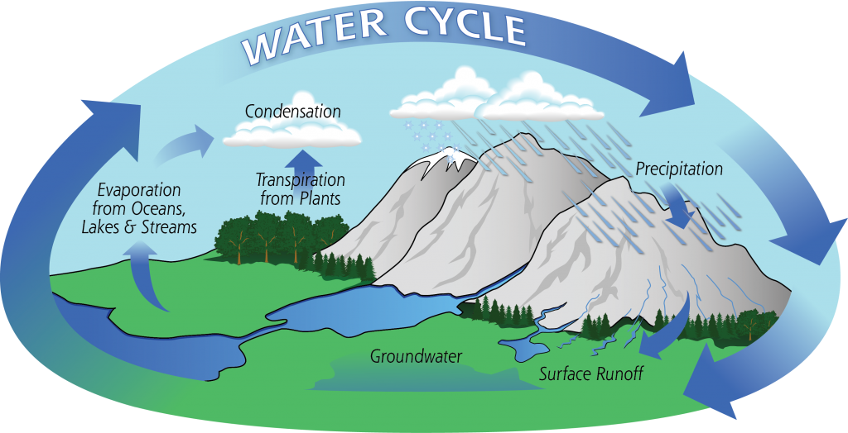Hydrologic Cycle | 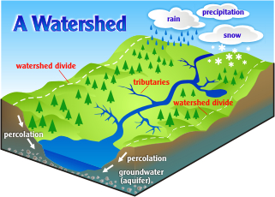Example of a watershed definition
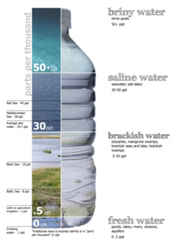  Scale of salinity ranging in ppt (parts per thousand) | 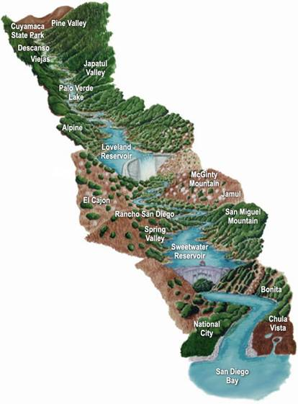  Example of watershed (Sweetwater) from headwaters to mouth
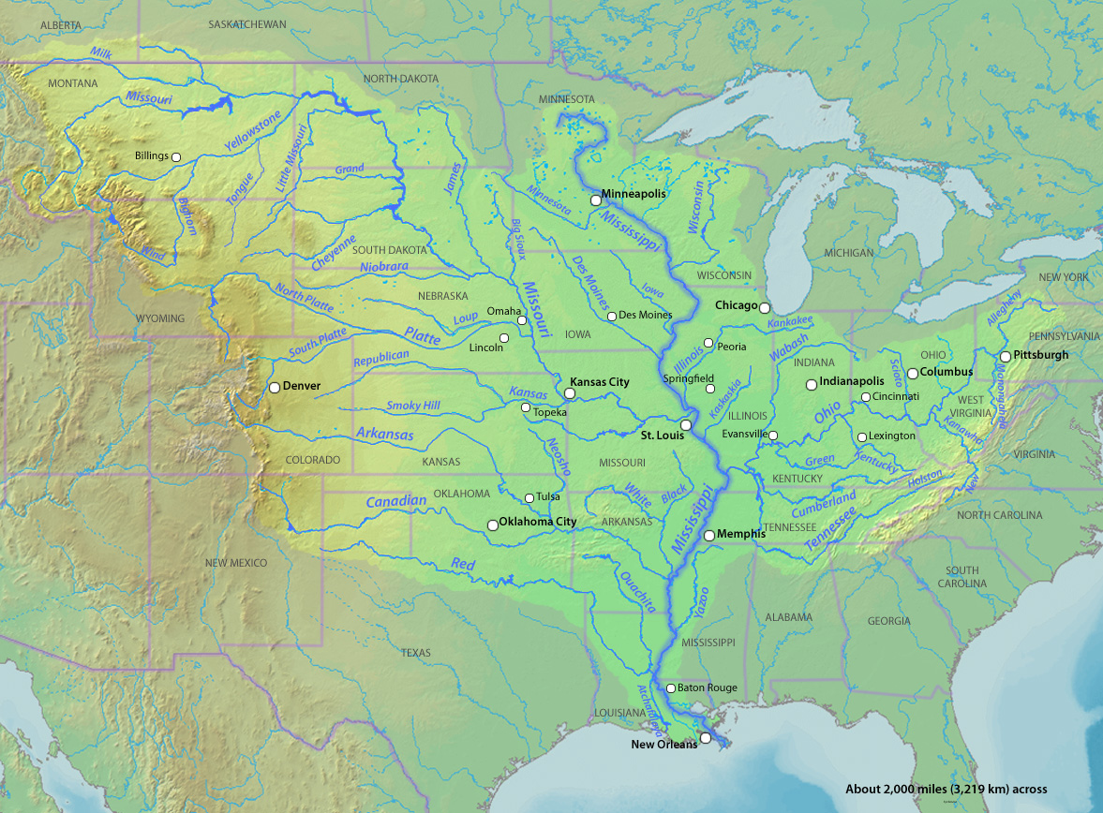  Mississippi River Watershed | 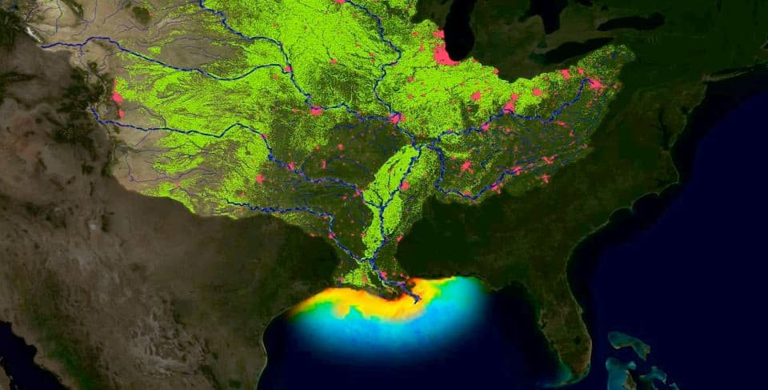Dead Zone from the Mississippi River runoff
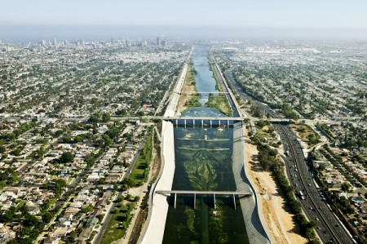Channelized Los Angeles River | 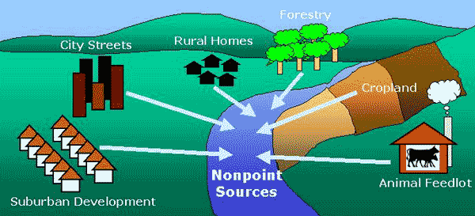Runoff (nonpoint sources) of pollution to a river.
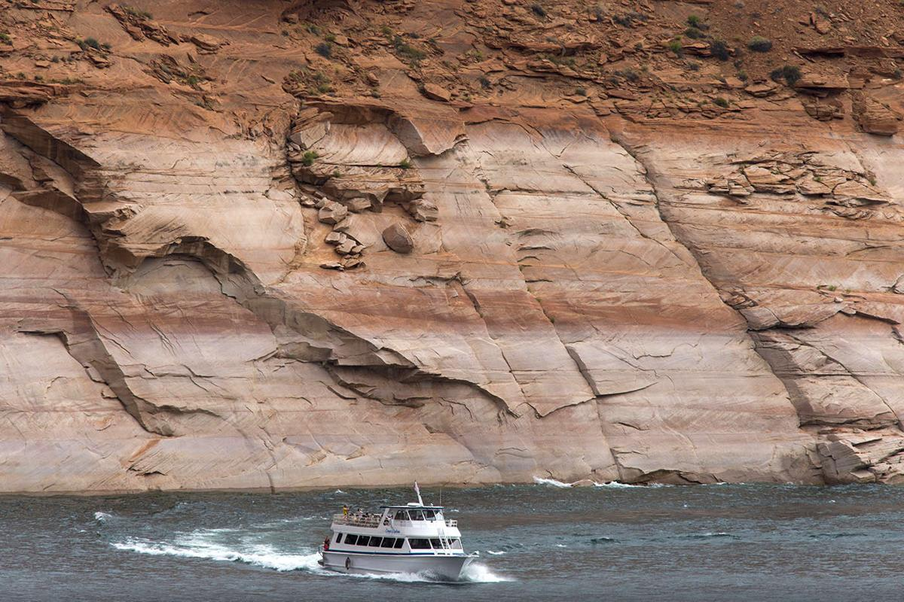Lake Powell after years of drought | 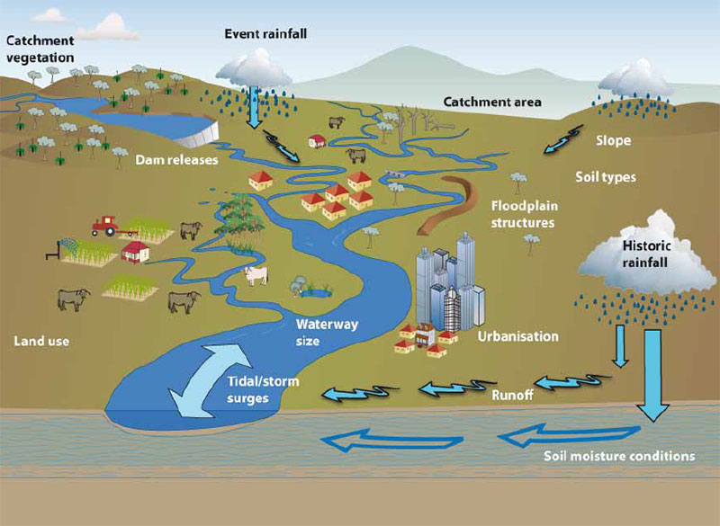  Infographic of what causes flooding
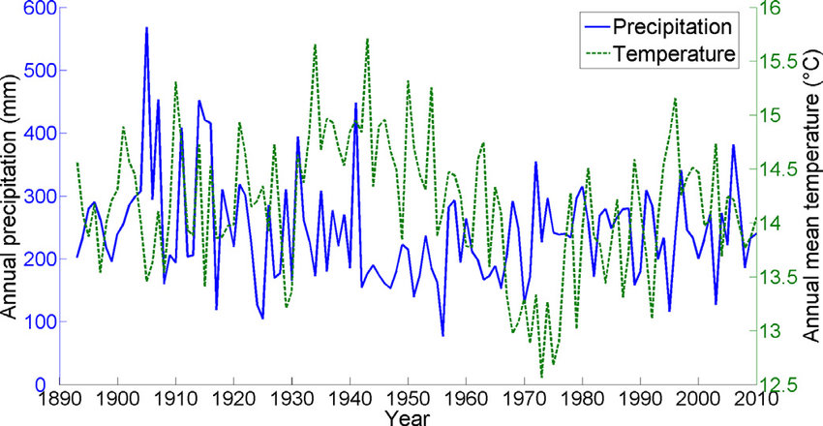  Example of precipitation and temperature chart measured over 150 years in NM | 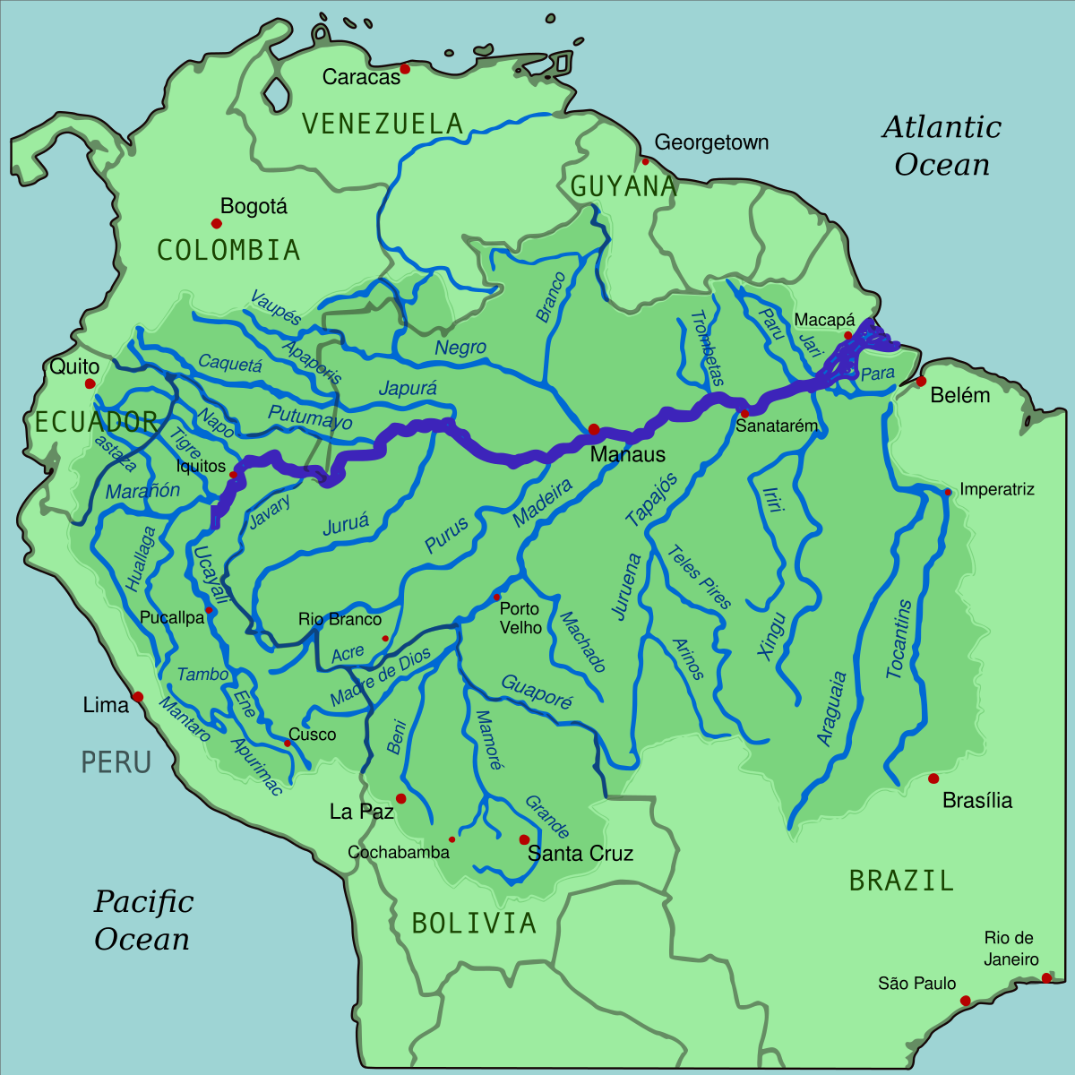  Amazon river watershed is about the size of continental USA

